Automation App Errors

1)Unknown Error in Login Response

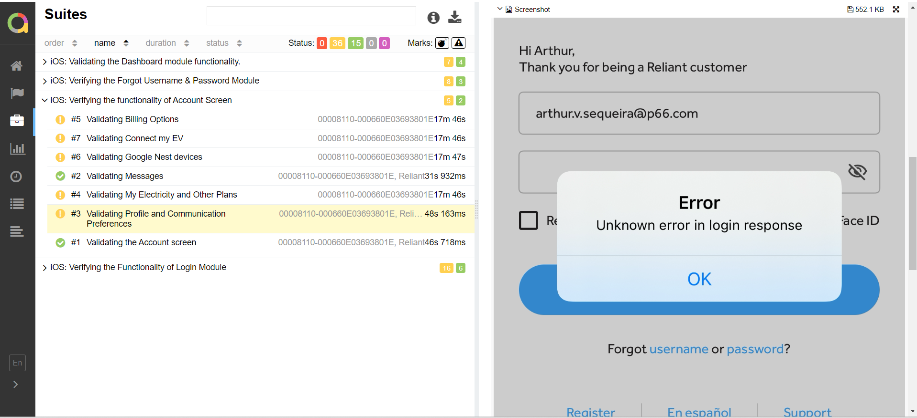

2)Technical Error

